Event Details

2026 Built with Claude: Life Sciences Participant Guide
Thank you for being part of the Built with Claude: Life Sciences 👋 This guide is your all-in-one resource for the event, including schedule, rules, technical resources, problem statements, judging information, and more. Please read this carefully; most answers can be found here.

1️⃣ Connect with the Community

Discord
Join the hackathon Discord server here: https://anthropic.com/discord

Join the Claude Discord Server!
Check out the Claude community on Discord - hang out with 112411 other members and enjoy free voice and text chat.
https://discord.com/invite/6PPFFzqPDZ

Please note: We will assign a custom role to your Discord handle so you will be able to see the hackathon specific channels. Ping @CV in the #hackathon-access channel if you do not receive the Hackathon Participant role within a few hours.

Socials
Use the hero image below on X and LinkedIn.

2️⃣ Hackathon Schedule
- Tuesday, July 7th
  - 12:00 PM (ET): Virtual Kickoff – rules, prizes, judging, technical talks
  - 12:30 PM (ET): Hacking officially begins; team formation on Discord
  - 5:00–6:00 PM (ET): Anthropic office hours (#office-hours)
- Wednesday, July 8th
  - 12:00–1:00 PM (ET): Live Session One - Overview of Claude Science with Alexander Tarashansky, Member of Technical Staff at Anthropic
  - 5:00–6:00 PM (ET): Anthropic office hours (#office-hours)
- Thursday, July 9th
  - 5:00–6:00 PM (ET): Anthropic office hours (#office-hours)
- Friday, July 10th
  - 12:00 PM–1:00 PM (ET): Live Session Two - From genome to inference without touching a pipette: virtual genome-wide PPI screening leads to real discoveries with Sukrit Silas, Assistant Investigator at Gladstone Institutes
  - 5:00–6:00 PM (ET): Anthropic office hours (#office-hours)
- Saturday, July 11th
  - All Day: Hacking continues
- Sunday, July 12th
  - All Day: Hacking continues
- Monday, July 13th
  - 9:00 PM (ET): Submissions due via CV platform
- Tuesday, July 14th
  - All Day: First round judging
- Wednesday, July 15th
  - All Day: First round judging
- Thursday, July 16th
  - 12:00 PM (ET): Final Round Judging
    - Top 6 teams announced (#announcements)
    - Final round judging
  - 1:30 PM (ET): Closing Ceremony
    - Top 3 revealed, celebration & closing remarks

3️⃣ Hackathon Rules
To keep things fair and aligned with our goals, all teams must follow these rules:
- Open Source: Everything submitted for you project must be open sourced. Your project should be published under an approved open-source license.
- New Work Only: All projects must be started from scratch during the hackathon with no previous work. Researchers: starting from an existing question and public datasets is fine, but the analysis must happen during the event.
- Team Size: Teams may have up to 2 members.
- Banned Projects: Projects will be disqualified if they: violate legal, ethical, or platform policies, use code, data, or assets you do not have the rights to.

4️⃣ Problem Statements & Example Projects

[Researcher Track] Build From the Bench
Using Claude Science, start from a biological question you've been thinking through and find the existing datasets and tools needed to answer it. Submit something discrete — a finding, a trained model, an analysis others can reproduce — and show us how Claude Science got you there.
Looking for ideas? These datasets from Gladstone Institutes are optional starting points:
- Look for new drug targets in the CD4+ T cell Perturb-seq data from Alex Marson's lab (code, preprint).
- Predict what a noncoding variant does to chromatin in a cell type you care about, the way Ryan Corces's lab does it — run their pre-trained brain models from the Corces Resources page, or train your own with ChromBPNet on any ENCODE ATAC-seq experiment.
- Find regions of the genome that are deeply conserved across mammals but changed rapidly in humans, using Katie Pollard's Zoonomia constraint scores and Human Accelerated Regions — then figure out what they might be doing.

[Builder Track] Build Beyond the Bench
Using Claude Code, start from a user you can name — a scientist, a lab, a clinic, a biotech — and build the tool they're missing: working software they could use without you in the room, built to outlast the week.
Looking for ideas? These datasets from Gladstone Institutes are optional starting points:
- A lab notebook companion for a wet-lab scientist — turns voice memos or rough notes from the bench into structured, searchable experiment records with protocols, reagents, and outcomes auto-tagged.
- A clinical trial matcher for a research coordinator — takes free-text patient notes and surfaces eligible trials from ClinicalTrials.gov, with the inclusion/exclusion reasoning shown for every match.
- A pipeline translator for a bioinformatician's collaborators — wraps an existing command-line analysis pipeline in an interface a bench scientist can run without touching the terminal.

5️⃣ Anthropic-Provided Resources

Quickstarts
- Claude Science Get Started
- Claude Code Quickstart
- Claude API Quickstart
- Claude Models Overview

Docs
- Claude Science Docs
- Claude Code Docs
- Claude API Docs
- MCP Docs
- Agent Skills Docs

Blogs
- Claude Science announcement
- Claude Code Best Practices
- Building Effective Agents
- Building Agents with the Claude Agent SDK
- Building multi-agent systems: when and how to use them
- Best practices for prompt engineering
- Effective Context Engineering
- Extending Claude’s capabilities with skills and MCP servers
- Skills explained: How Skills compares to prompts, Projects, MCP, and subagents
- Building agents with Skills: Equipping agents for specialized work
- Claude Code power user customization: How to configure hooks

Courses
- Claude Code in Action
- Agent Skills with Anthropic
- Claude Code Courses GitHub

Other
- Claude Quickstarts - A collection of projects designed to help developers quickly get started with building deployable applications using the Claude API
- Claude Science Product overview
- A Complete Guide to Building Skills for Claude (eBook)
- Claude Cookbooks and Cookbooks Github Repo
- Agent Skills Github Repo

6️⃣ Judging
Judging for the Anthropic Virtual Hackathon happens in two stages:

Stage 1 - Asynchronous Judging
- Date: Tuesday, July 14 – Wednesday, July 15, 2026
- How it works:
  - Judges review your submitted projects asynchronously via the judging platform.
  - Each team will have uploaded:
    - A short demo video (3 minute maximum)
    - Open source project repository, notebook, or research write-up
    - Written summary (100–200 words)
  - Judges independently evaluate projects using standardized criteria.
Judging Criteria:
    - Impact (25%) — What's the real-world potential here? Who benefits, and how much does it matter? For Builder projects: could this become something people use? For Researcher projects: is this a finding or analysis others can build on? Does it fit your track's problem statement?
    - Claude Use (25%) — How creatively did this team use Claude Code? Did they go beyond a basic application? Did they surface capabilities that surprised even us?
    - Depth & Execution (20%) — Did the team push past their first idea? Is the engineering sound and thoughtfully refined? Does this feel like something that was wrestled with — real craft, not just a quick hack?
    - Demo (30%) — Is this a working, compelling demo? Does the project hold up — as software you could use, or findings you trust? Is it genuinely cool to watch?
  - After evaluation, the team aggregates scores to determine the Top 3 projects for each track for the final round

Stage 2 - Final Round Live Judging
- Date & Time: Thursday, July 16, 2026, 12:00 PM ET
- Format:
  - During the live session, pre-recorded demos from each team will be played (3 minutes per team).
  - Judges will deliberate after all demos to determine the winners and runner-ups for each category.
  - The two winners, runner-ups, and special prize winners will be announced during the closing ceremony at 1:30 PM ET.

7️⃣ Submission Instructions
- Submit your project below:

Built with Claude: Life Sciences
- Join us for Built with Claude: Life Sciences, a global virtual hackathon in partnership with Gladstone Institutes, a biomedical research organization in San ... | Tuesday, July 7, 2026 • Remote
- https://cerebralvalley.ai/e/built-with-claude-life-sciences/hackathon/submit
- 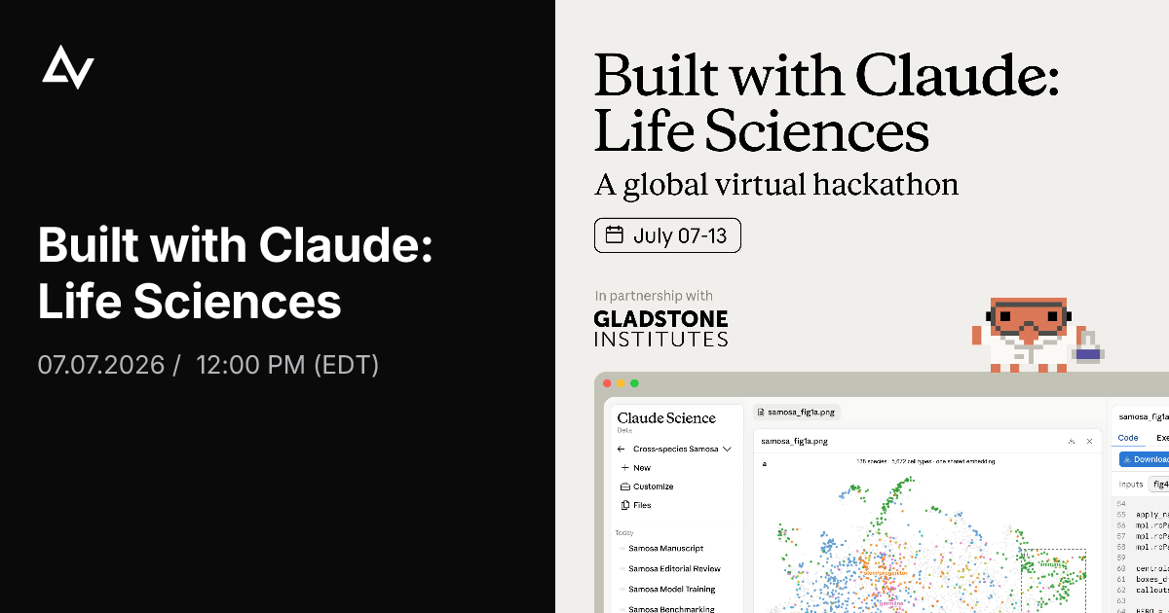
- Required for submission:
  - 3-minute demo video (YouTube, Loom, or similar)
  - GitHub repository, notebook, or research write-up
  - Written description / summary
- Deadline: July 13, 9:00 PM ET
- Make sure your project was built entirely during the hackathon; no pre-existing work is allowed. Researchers: starting from an existing question and public datasets is fine, but the analysis must happen during the event.

8️⃣ Prizes

Research Track
- 1st – $30,000 in usage credits
- 2nd - $10,000 in usage credits
- 3rd - $5,000 in usage credits

Builder Track
- 1st – $30,000 in API credits
- 2nd - $10,000 in API credits
- 3rd - $5,000 in API credits

The Gladstone Institutes Award – [$10k in usage Credits]
- This prize recognizes the research project with the most potential to advance the field, and is hand-selected by the Gladstone Institutes team.
❓If you have any questions, please ping in #questions or reach out to moderators.
On this page
2026 Built with Claude: Life Sciences Participant Guide
1️⃣ Connect with the Community
Discord
Socials
2️⃣ Hackathon Schedule
3️⃣ Hackathon Rules
4️⃣ Problem Statements & Example Projects
[Researcher Track] Build From the Bench
[Builder Track] Build Beyond the Bench
5️⃣ Anthropic-Provided Resources
Quickstarts
Docs
Blogs
Courses
Other
6️⃣ Judging
Stage 1 - Asynchronous Judging
Stage 2 - Final Round Live Judging
7️⃣ Submission Instructions
8️⃣ Prizes
Research Track
Builder Track
The Gladstone Institutes Award – [$10k in usage Credits]

